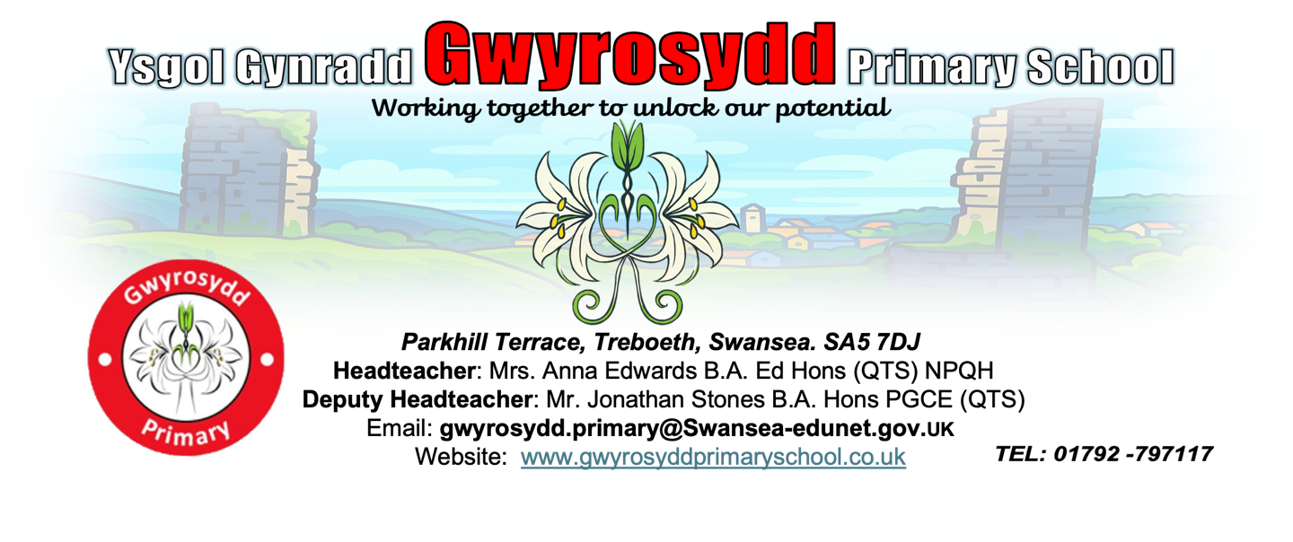

Polisi

Positive Behaviour and Relationships

Policy 2025

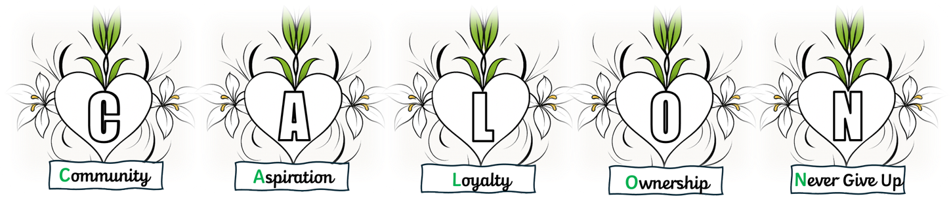

1. Introduction and Aims

Gwyrosydd Primary School is committed to the emotional mental health and well-being of its staff, pupils and parents/carers. We wish to work towards this in all aspects of school life and provide an ethos, environment and curriculum that supports the social, emotional and mental health of the whole school community. It is acknowledged that members of the school community may have very different parenting experiences and views on emotion and behaviour. However, the aim of this policy is to bring us all together to adhere to some basic key principles and practices that reflect our school ethos. We believe that: being ‘fair’ is not about everyone getting the same (equality) but about everyone getting what they need (equity). Behaviour is a form of communication and our approach aims to promote a shift towards viewing behaviour as a communication of an emotional need (whether conscious or unconscious), and to respond accordingly. We believe that taking a non-judgmental, curious and empathic attitude towards behaviour encourages all adults in school to respond in a way that focuses on the feelings and emotions that might drive certain behaviour, rather than the behaviour itself. We also believe that behavioural and emotional difficulties are regarded as vulnerability rather than being seen as troublesome and we all have a duty to explore this vulnerability and provide appropriate support.

Aims

- To maintain a caring, orderly community in which effective learning can take place and where there is mutual respect between members.
- To help pupils develop a sense of worth, identity, belonging and achievement.
- To help all pupils to become self-regulating but to also offer support to pupils that need guidance to regulate.
- For pupils to accept responsibility for their own actions and make positive choices.
- To develop in all pupils the ability to listen to others, cooperate and to appreciate other ways of thinking and behaving.

We strive to achieve these aims through this policy, our Curriculum and the United Nations Convention of Rights of the Child – developing an understanding of rights, responsibilities and respect. Praise, rewards, privileges and positive role-modelling support the development of self-discipline and the capacity to make positive choices. Our approach to learning supports recognition and inclusion for all within the local, national and international community. Our work with the community builds sustainability in relationships and connects our pupils with relevant learning opportunities.

2. Scope

This policy is for all staff, pupils, parents and carers, governors, visitors and partner agencies working within the school and provides guidelines and procedures as to how our school supports and responds to emotions and behaviour.
3. Guiding Principles

This policy is based on our approach to Restorative Practice and the ethos of “Ready, Respectful, Safe.” We also use our CALON values to promote positive behaviour and relationships across the whole school community.

- Community
- Aspiration
- Loyalty
- Ownership
- Never Give Up

This policy has included input from members of staff, the governing body, parents and carers and most importantly our pupils.

4. Roles and Responsibilities

At Gwyrosydd Primary School, maintaining positive emotional well-being and behaviours, is the responsibility of all staff, governors, parents and carers and pupils. We expect all our staff and parents and carers to be positive role models for our pupils as we develop their attitudes towards all aspects of life.

5. Approach

At Gwyrosydd Primary School we put relationships first. We aim to develop a school ethos that promotes strong relationships between staff, pupils and parents and carers. It also relies on creating a positive school culture and climate that fosters connection, inclusion, respect and value for all members of the school community. We maintain clear boundaries and expectations around behaviour. Changing how we respond to behaviour does not mean having no expectations, routines or structure. To help our pupils, they need to feel safe and their educational environment needs to be high in both nurture and structure; they need predictable routines, expectations and responses to behaviour. These are achieved by developing and embedding Restorative Practice and the “Ready, Respectful, Safe” ethos. Rewards and consequences should be made explicit, without the need to enforce ‘sanctions’ that can shame and ostracise pupils from their peers, school community and family, leading to potentially more negative behaviour. Not all behaviours are a matter of ‘choice’ and not all factors linked to the behaviour of the child are within their control. Therefore, the language of choice should be carefully considered. Encouraging parental engagement and involvement is crucial when addressing and planning support for a child’s personal and emotional needs. We will endeavour to inform parents and carers, wherever possible, of our approach.
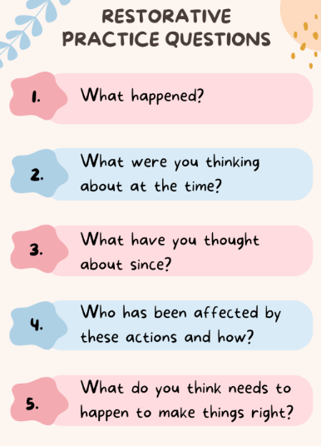

We follow a graduated response when supporting pupils with their behaviour:

Graduated Response
Universal Provision  Identify need | Targeted Support  Intervene | Specific Support  Further intervention (multi-agency)
Whole School Approach

CALON Values Restorative Practice Ready, Respectful, Safe Pupil Voice Engaging Curriculum

- Positive behaviour management  - Regular check-ins  - Regular breaks if needed  - Regulation station/calm area  - Visual time table  - Now and Next boards/cards  - Mindfulness activities  - Growth mindset  - Effective differentiated work that supports independence and builds confidence  - Fidget toys  - Class charters developed with the pupils  - Zones of Regulation | - One page profile  - Individual Behaviour Plan (IBP) with voice of the pupil taken into account  - Behaviour chart with voice of the pupil taken into account  - Positive Play  - ELSA  - Allocated time for bespoke intervention  - Support from Family Engagement Officer (FEO) | - Exchange/Platform  - CAHMS  - Behaviour Support  - Educational Psychologist  - Reduced Timetable  - Individual Development Plan (IDP)  - Prevent  - Media Academy

6. Monitoring and Review

The school is committed to ensuring that this policy has a positive impact on the pupil’s education, behaviour and welfare.

When reviewing the policy, the school will consider:
- Feedback from pupils
- Feedback from parent and carers
- Feedback from staff
- Records of behaviour and safeguarding incidents
- Relevant advice from the Welsh Government, the local authority or other relevant organisations

7. Contact Information

For any questions or concerns regarding this policy, please contact:

School Name: Gwyrosydd Primary School
Address: Parkhill Terrace, Treboeth, Swansea, SA5 7DJ
Phone: 01792 797117
Email: gwyrosydd.primary@swansea-edunet.gov.uk


Date 10th November 2025

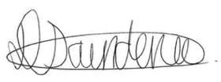
Headteacher: Anna Edwards Signature:
Chair of Governors: Donna Saunders Signature:
Review date: November 2027

