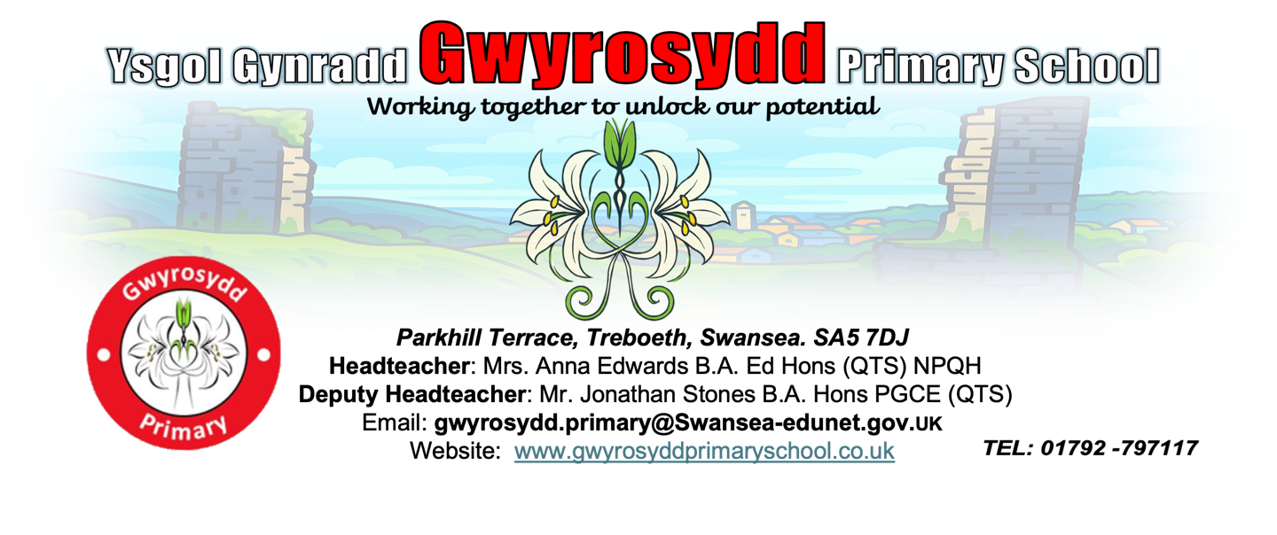

Polisi

Anti-Bullying Policy

Policy 2025

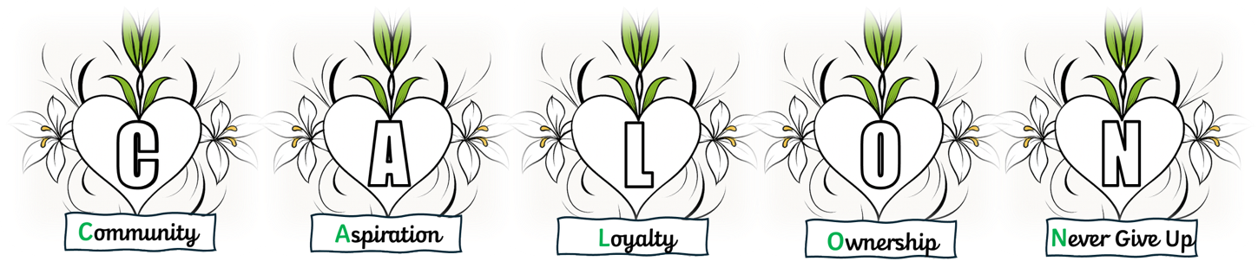

1. Introduction and Aims

Gwyrosydd Primary School is a place where every person has the right to be themselves and to be included in a safe, nurturing and happy environment. Every member of our school community is equal and treats each other with respect and kindness.

Aims

Bullying of any kind is unacceptable and will not be tolerated at Gwyrosydd Primary school. At Gwyrosydd Primary School the safety, welfare and well-being of all pupils and staff is a key priority. We take all incidences of bullying seriously and it is our duty as a whole school community to take measures to prevent any bullying, harassment or discrimination. We actively promote our CALON values and work to ensure that difference and diversity is celebrated across the whole school community. We want to enable our pupils to become responsible citizens and to prepare them for life in 21st Century Wales. These values reflect those that will be expected of our pupils, by society, when they enter secondary school and beyond in the world of work or further study. We are committed to improving our school’s approach to tackling bullying and regularly monitor, review and assess the impact of our preventative measures.

2. What us bullying?

There are many forms of bullying. Bullying is hurtful or unkind behaviour which is deliberate and repeated over time. Bullying can be carried out by an individual or a group of people towards another individual or group.

The STOP acronym can be applied to define bullying – Several Times On Purpose.

At Gwyrosydd Primary School, we identify these as types of bullying (but this is not an exhaustive list):

- Physical – such as hitting or physically intimidating someone, or using inappropriate or unwanted physical contact towards someone.
- Attacking property – such as damaging, stealing or hiding someone’s possessions.
- Verbal – such as name calling, spreading rumours about someone, using derogatory offensive language or threatening someone.
- Psychological – such as deliberately excluding or ignoring people.
- Cyber – such as using text, email or social media to write or say hurtful things about someone.

In addition, the Welsh Government has identified these specific ‘types’ of identity-based bullying:

- Bullying around race, religion and culture.
- Bullying involving learners with special educational needs and disabilities.
- Homophobic bullying.
- Sexist, sexual and transphobic bullying.

Bullying can happen in any situation and at any stage of our lives. Bullying is about reducing the freedom of others; not respecting another person’s rights or space. Bullying is not only a school issue - it is a whole community issue. Bullying is unacceptable between anyone and it goes against our CALON values.

As a school we recognise bullying can, and sometimes does, happen. We encourage all our pupils to speak openly and honestly about any incidents that they feel involve bullying whether they are the victim or not. We aim to follow up all reported incidents of bullying immediately. We investigate; we listen and enquire. We do it gently and carefully, working with the people who are involved. Some investigations can take time to conduct as bullying can be complex and can have a long history. However, any complaints will be given the appropriate care and attention so that a positive outcome can be reached. Where bullying is proven, we then seek to stop it. Support is put in place to ensure that this happens.

3. Procedures for dealing with incidents of bullying

Pupils who are being bullied

If a pupil is being bullied, they are encouraged to not retaliate but to tell someone they trust about it. Pupils can report bullying to:

- A teacher – their class teacher, or any other member of teaching staff.
- Another adult in school – such as lunchtime supervisors, teaching assistants, office staff or caretaker.
- A friend, who in turn can help them tell a teacher or member of staff.
- An adult at home or an adult who runs a club that they may attend out of school.
- Child Line on 0800 1111.

Reporting - roles and responsibilities

Senior Leadership Team
The Headteacher, Deputy Headteacher and members of the Senior Leadership Team (SLT) have overall responsibility for ensuring that the anti-bullying policy is followed by all members of staff and that the school upholds its duty to promote the safety and well-being of all pupils.

Staff
All school staff, both teaching and non- teaching, have a duty to report bullying, to be vigilant to the signs of bullying and to play an active role in the school’s efforts to prevent bullying. If staff are aware of bullying, they should reassure the pupils involved and inform a relevant member of the SLT or pastoral team.

Parents and carers
Parents and carers should look out for potential signs of bullying, such as distress, lack of concentration, feigning illness or other uncharacteristic behaviour. Parents should encourage their child not to retaliate and support and encourage them to report the bullying. Parents and carers can report an incident of bullying to the school either in person, or by phoning or emailing the school office or a member of staff. They can also communicate through channels such as Class Dojo.

Pupils
Pupils should not take part in any kind of bullying and should watch out for potential signs of bullying among their peers. They should never be bystanders to incidents of bullying. If pupils witness bullying they should support the victim, encourage them to report the bullying and, if possible, help them to tell a trusted adult.

If bullying is proved then the following would take place:

- Staff to speak with the pupil(s) who have been bullied and offer appropriate support.
- Staff to speak with the pupil(s) who have been bullying and offer support in order to help them stop the bullying behaviour.
- A restorative practice meeting will take place, between all pupils, when the victim(s) of bullying feel safe, secure and ready for that meeting to take place.
- Parents/carers will be notified and meetings held if necessary.
- All staff, who work with pupils, will be made aware of the situation so that they are able to be vigilant and offer support.

Consequences for bullying behaviour could include:

- A withdrawal at social times such as break times.
- A withdrawal from privileges that are over and above the general curriculum that we offer every child.
- Exclusion from school is the last resort. All avenues of support and guidance would be explored first.

4. Maintaining an anti-bullying initiative

It is important that the issue of maintaining a safe, inclusive school environment retains a high priority each year. This is done through regular staff training, through our Relationships and Sex Education (RSE) curriculum, community workshops and awareness raising exercises such as assemblies, anti-bullying days etc...

5. Monitoring and Review

The school is committed to ensuring that this policy has a positive impact on the pupil’s education, behaviour and welfare.

When reviewing the policy, the school will consider:
- Feedback from pupils.
- Feedback from parent and carers.
- Feedback from staff.
- Records of behaviour and safeguarding incidents.
- Relevant advice from the Welsh Government, the local authority or other relevant organisations.

6. Contact Information

For any questions or concerns regarding this policy, please contact:

School Name: Gwyrosydd Primary School
Address: Parkhill Terrace, Treboeth, Swansea, SA5 7DJ
Phone: 01792 797117
Email: gwyrosydd.primary@swansea-edunet.gov.uk
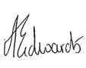

Date 19th November 2025

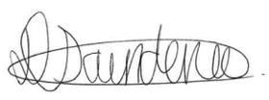
Headteacher: Anna Edwards Signature:
Chair of Governors: Donna Saunders Signature:
Review date: November 2027

