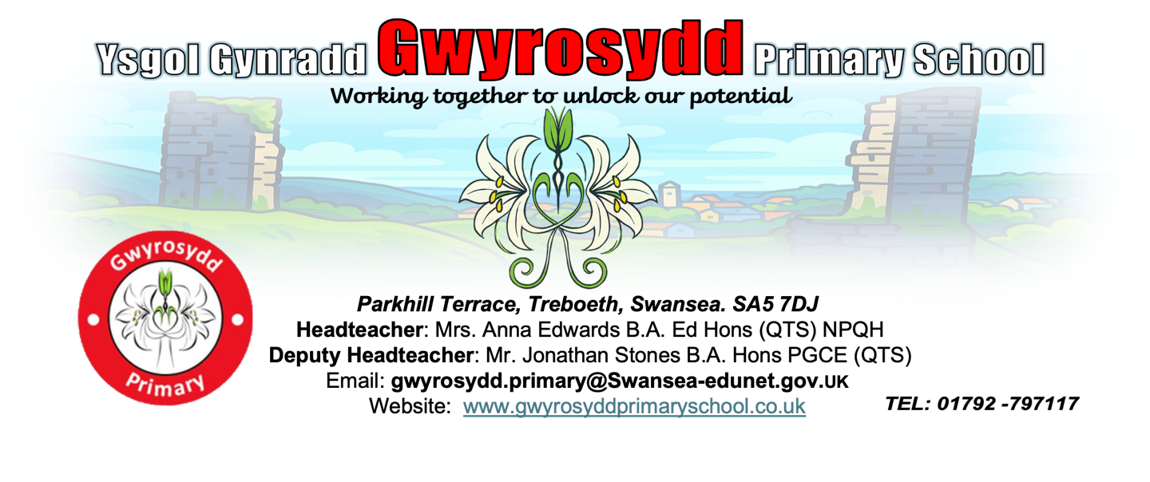

Polisi

Teaching and Learning

Policy

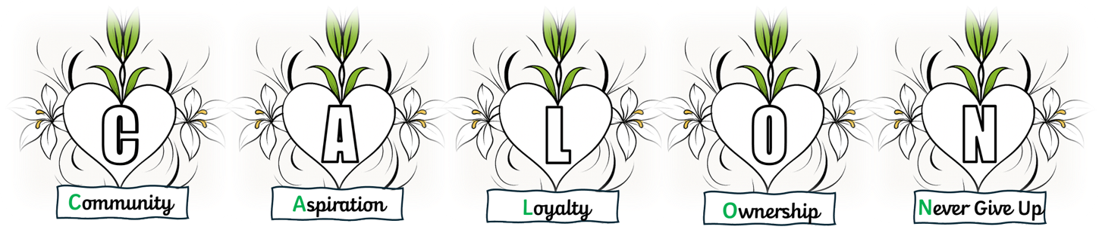

Vision Statement
At Gwyrosydd, we believe that every child deserves the best possible start in life, and we are committed to providing a high-quality education that inspires, challenges, and supports all learners to achieve their full potential.
Our school is a place where curiosity is encouraged, creativity is celebrated, and kindness is at the heart of everything we do. We value strong relationships with our families and the wider community, and we work in partnership to create a safe and stimulating environment where children feel happy, confident, and motivated to learn.
How will we achieve this?
- To have high expectations of all children
- Putting the personal development and well-being of our pupils first
- Providing a broad, constantly evolving, innovative, exciting, forward-thinking curriculum that enriches and challenges and takes account of the pupil voice
- To provide quality teaching and learning for all our pupils in a safe, secure, happy, healthy, caring and stimulating environment. A curriculum for the development of the whole child and one that is fitting for 21st Century Wales
- To provide challenging and motivating experiences that allow the children to be reflective, take responsibility and show initiative
- Being an inclusive school that uses a wide range of teaching and learning strategies, technologies and high-quality resources in order to ensure that all learners reach their full potential
- Maximising the time allocated to learning
- To develop attitudes, characteristics, knowledge and a range of skills that will prepare the children for the opportunities, responsibilities and experiences of a modern society
- To encourage, praise and positively reinforce good relationships and behaviour.
- To create a school culture that fosters good communication, openness and a sense of belonging within a supportive community for all children, parents, staff and governors
- Working in partnership with parents, acknowledging and supporting their role as the primary educators of their children and providing them with the information to help their children learn well
- Creating a happy, industrious atmosphere that models, promotes and celebrates good behaviour
- To continue to develop Gwyrosydd as a school committed to continuous improvement by involving all of our stakeholders

The ethos of our school
At Gwyrosydd Primary School, we promote an approach to teaching and learning that actively engages all stakeholders; encouraging independent and individual thinking and responses, developing our school as an effective learning 0rganisation. At Gwyrosydd Primary, Pupil Voice, fun, relevant and real-world learning resources lie at the heart of all learning experiences and we collaboratively create an environment where the desire to learn comes from the individuals themselves. Our underpinning principle is that learning becomes more valued and enjoyable when content and processes are learned in the context of real and present problems to be solved and questions to be answered. Our enriched curriculum and education stimulates meaningful, substantial and rewarding learning experiences for every individual.

Our Values
At Gwyrosydd we have five school values that were developed after consultation with pupils, staff, governors and parents. These values are visible throughout the school, with the language from these values and their descriptors being used day-to-day, such as in whole school assemblies, certificates, feedback and conversations with learners. The five values are presented as the acronym C.A.L.O.N and are as follows:

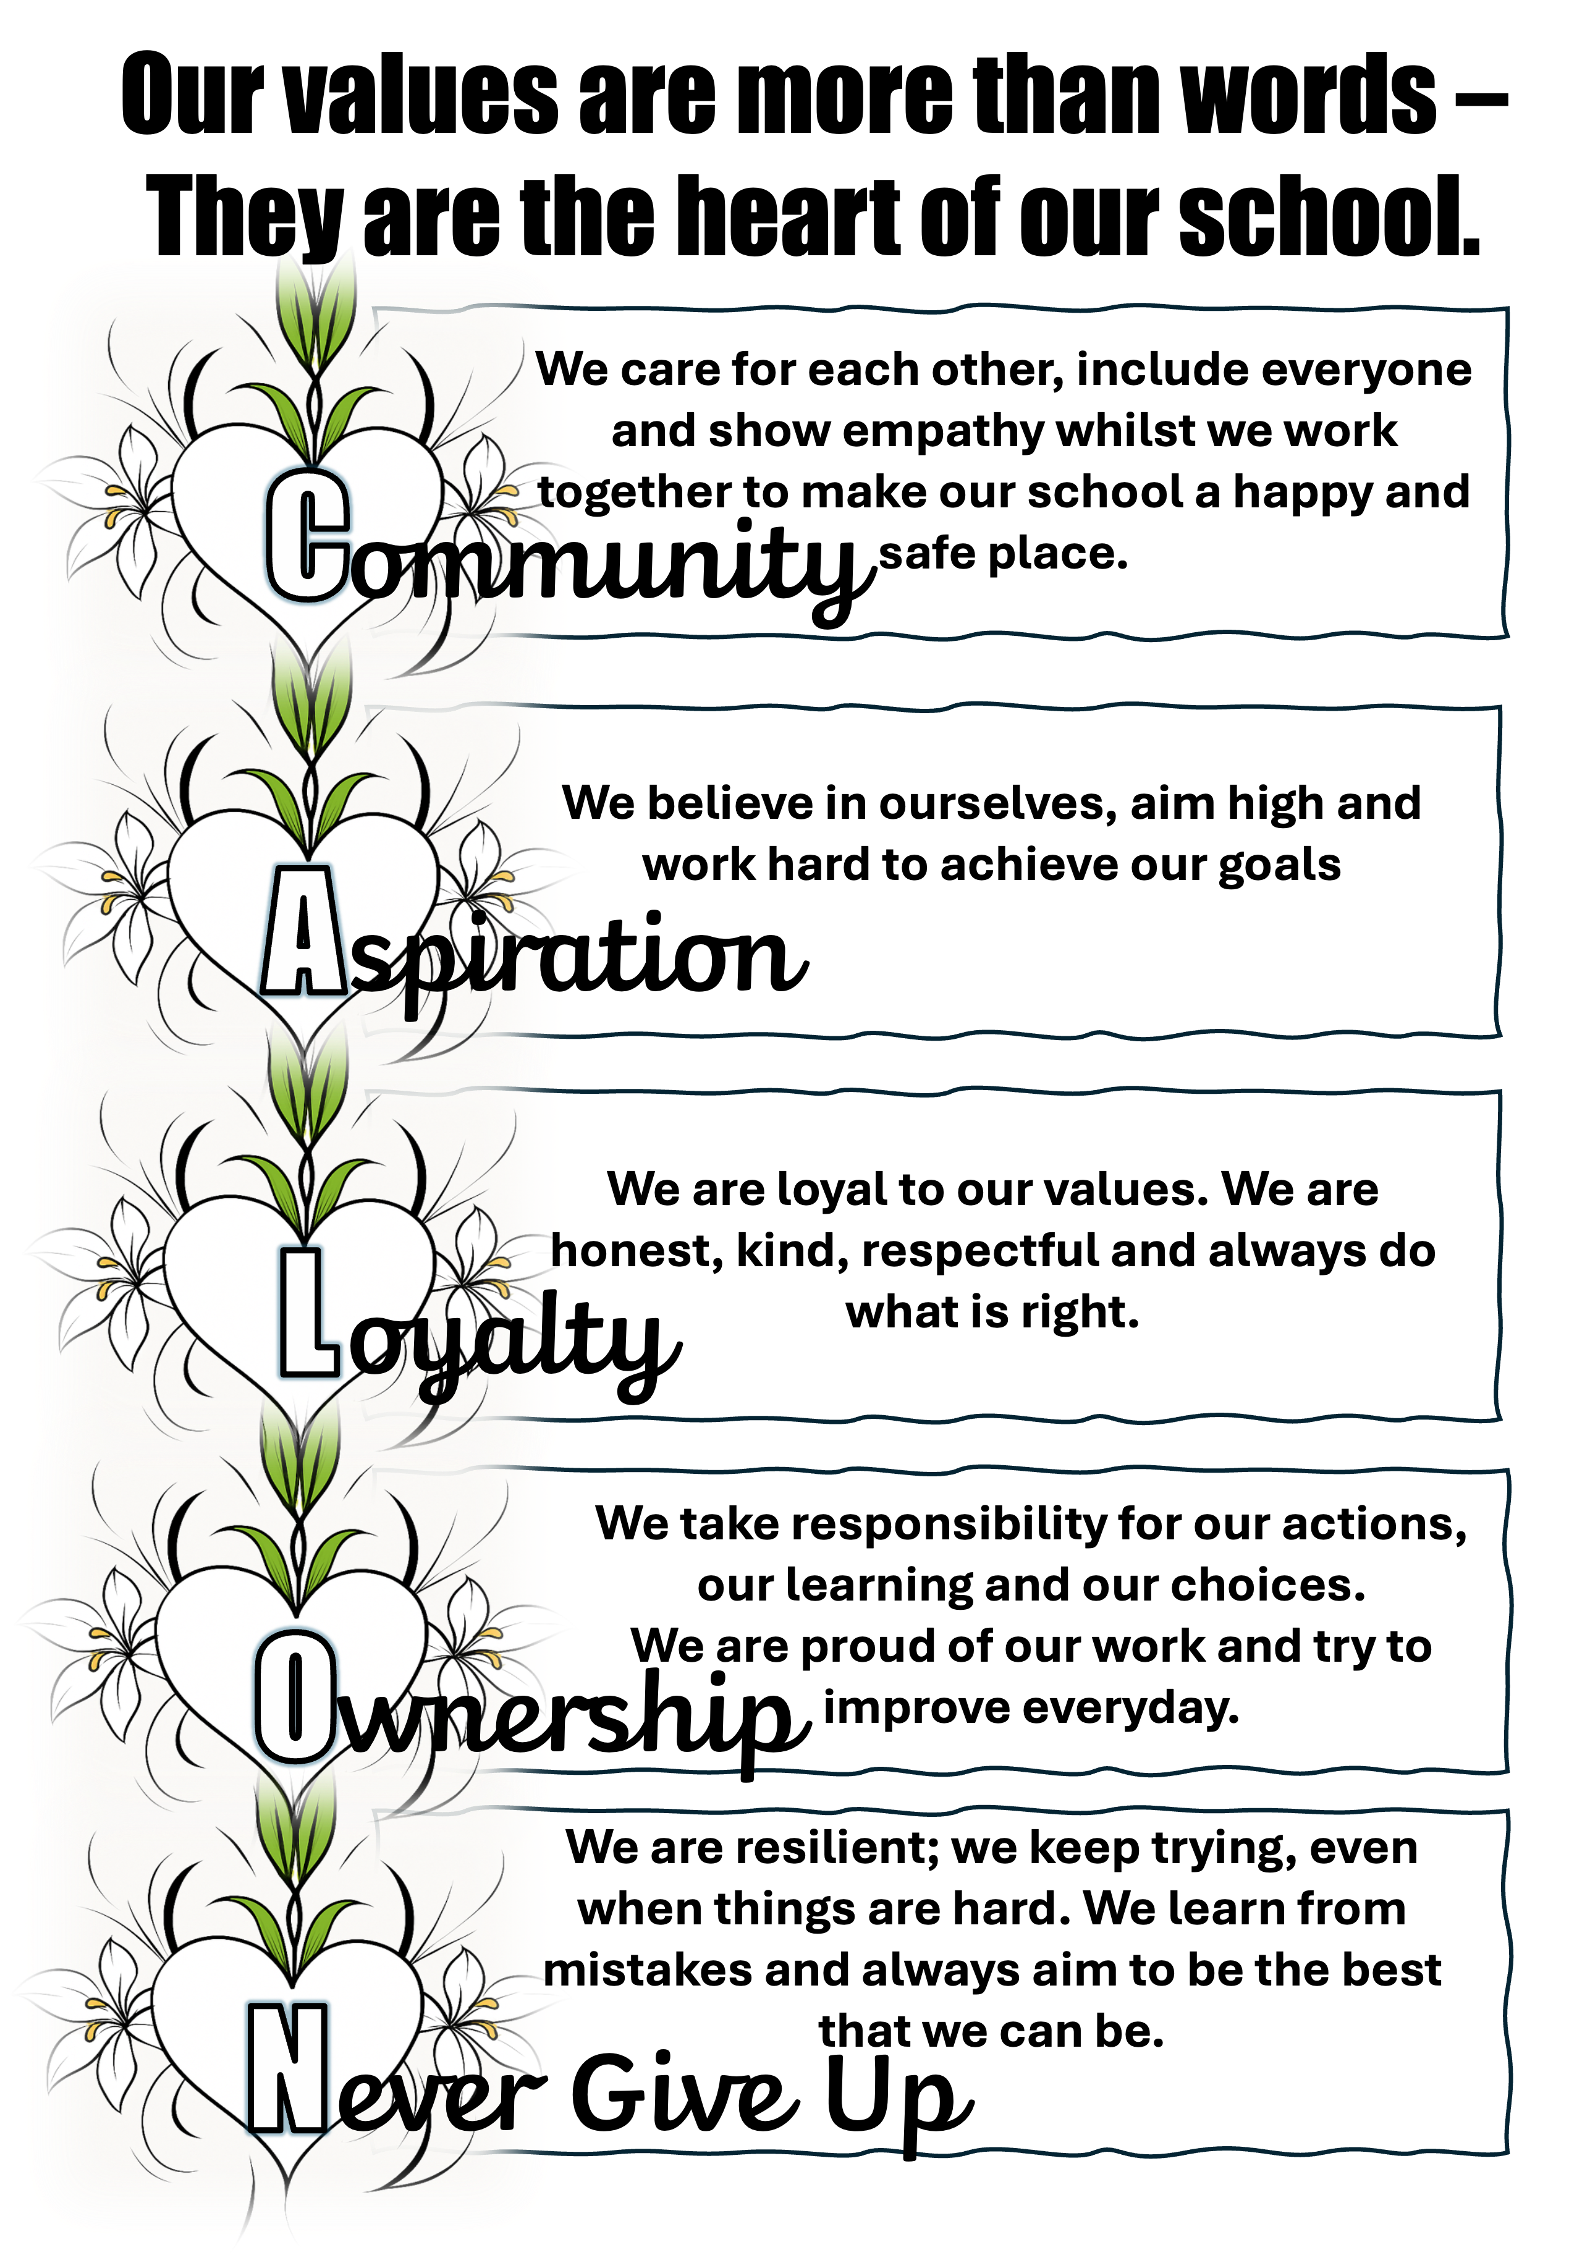

These values aim to guide learners in developing positive attitudes and to build the skills needed to shape the mindsets and behaviour of our future community.

Our curriculum is underpinned by our values. Each term, we have a whole school focus on a value which ensure that our pupils are explicitly taught and inspired through engaging and authentic themes and contexts.

Curriculum, Learning and Experiences
At Gwyrosydd we recognise:

‘There is a range of competences and skills which are foundations for almost all learning and are essential to being able to participate successfully and confidently in the modern world’ (Successful Futures: 2015)

At Gwyrosydd we believe that every experience is a learning experience and we pride ourselves in making these experiences fun and memorable whilst equipping staff and pupils with the skills, knowledge and understanding necessary to make informed choices about the important things that impact their lives and embed the skills needed for lifelong learning.

The Four Core Purposes
Teachers and pupils place the Four Core Purposes of the new curriculum at the heart of all learning experiences. The four purposes ensure that our pupils at Gwyrosydd are:

1. Ambitious, capable learners who: – set themselves high standards and seek and enjoy challenge – are building up a body of knowledge and have the skills to connect and apply that knowledge in different contexts – are questioning and enjoy solving problems – can communicate effectively in different forms and settings, using both Welsh and English – can explain the ideas and concepts they are learning about – can use number effectively in different contexts – understand how to interpret data and apply mathematical concepts – use digital technologies creatively to communicate, find and analyse information – undertake research and evaluate critically what they find and are ready to learn throughout their lives

2. Enterprising, creative contributors who: – connect and apply their knowledge and skills to create ideas and products – think creatively to reframe and solve problems – identify and grasp opportunities – take measured risks – lead and play different roles in teams effectively and responsibly – express ideas and emotions through different media – give of their energy and skills so that other people will benefit and are ready to play a full part in life and work

3. Ethical, informed citizens who: – find, evaluate and use evidence in forming views – engage with contemporary issues based upon their knowledge and values – understand and exercise their human and democratic responsibilities and rights – understand and consider the impact of their actions when making choices and acting – are knowledgeable about their culture, community, society and the world, now and in the past – respect the needs and rights of others, as a member of a diverse society – show their commitment to the sustainability of the planet and are ready to be citizens of Wales and the world

4. Healthy, confident individuals who: – have secure values and are establishing their spiritual and ethical beliefs – are building their mental and emotional well-being by developing confidence, resilience and empathy – apply knowledge about the impact of diet and exercise on physical and mental health in their daily lives – know how to find the information and support to keep safe and well – take part in physical activity – take measured decisions about lifestyle and manage risk – have the confidence to participate in performance – form positive relationships based upon trust and mutual respect – face and overcome challenge – have the skills and knowledge to manage everyday life as independently as they can and are ready to lead fulfilling lives as valued members of society.

At Gwyrosydd we envisage these core purposes overlapping and developing through rich learning opportunities throughout all Areas of Learning Experience (AoLE).

Areas of Learning Experience (AoLE)
All Areas of Learning and Experience (AoLE) are underpinned by rich learning experiences which include opportunities to develop numeracy, literacy and digital competency skills. All aspects of each AoLE are assessed and monitored, by our AoLE Teams, through rigorous self-evaluation activities that allow us to formulate short, medium and long term development targets which lead to school improvement and real positive impact.

The principles underpinning every AoLE at Gwyrosydd ensures that the curriculum is:-
• authentic: rooted in Welsh values and culture and aligned with four purposes
• evidence-based: drawing on the best of existing practice within Wales and from elsewhere, and on sound research
• responsive: relevant to the needs of today (individual, local and national) but also equipping all young people with the knowledge, skills and character for future challenges as lifelong learners
• inclusive: easily understood by all, encompassing an entitlement to high-quality education for every child and young person and taking account of their views in the context of the United Nations Convention on the Rights of the Child (UNCRC), and those of parents, carers and wider society
• ambitious: promoting high expectations and setting no limits on achievement and challenge for each individual child and young person
• empowering: developing capabilities which will allow young people to engage confidently with the challenges of their future live
• unified: enabling continuity and flow with components which combine and build progressively
• engaging: encouraging enjoyment from learning and satisfaction in mastering challenging subject matter
• based on subsidiarity: commanding the confidence of all, while encouraging appropriate ownership and decision making by those closest to the teaching and learning process
• manageable: recognising the implications for and supported by appropriate assessment and accountability arrangements. Teachers apply the pedagogical principles identified in Successful Futures when planning their teaching and learning, to ensure that the activities relate directly to the curriculum purposes.

Effective Teaching & the 12 Pedagogical Principles:
At Gwyrosydd we aim to provide a caring, supportive, stimulating and safe environment. We ensure the best possible environment for learning by developing a positive atmosphere where pupils feel safe and feel they belong, where they enjoy being challenged, but where they enjoy learning, and know that they will succeed.

Effective teaching and learning experiences at Gwyrosydd are underpinned by the 12 pedagogical principles identified in Successful Futures 2015:
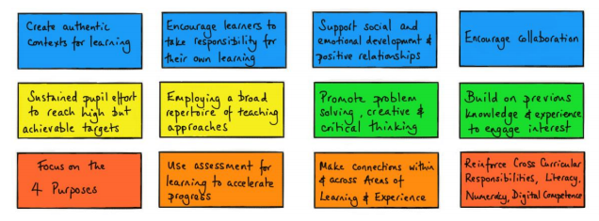

At Gwyrosydd these principles permeate our curriculum through our teaching and learning and help us to develop our ethos. When we are teaching, we focus on motivating all the children, and build on their skills, knowledge and understanding of skills, so that they reach the highest level of personal achievement. To help us achieve this we use a thematic approach across the school. The school uses termly planning overviews to guide teaching and learning experiences that are centred around a whole school value of the term. These planning models clearly set out a ‘hook’ for learners, making experiences authentic and engaging; cross cutting themes (Relationships and Sexuality Education (RSE), human rights (UNCRC), diversity, careers and work-related experiences, local, national and international contexts); linked literature; and skills and experiences based on ‘What Matters’ statements and the Four Purposes of Learning from the Curriculum for Wales. Our planning models allow flexibility for pupil inspired learning, through EPIC planning (Everyone Planning in Class), promoting engagement and enthusiasm for learning. Termly themes are mapped out in a two-year cycle in ‘Pods’ that ensure progression and skill coverage and development. Teachers make ongoing whole class assessments of learner progression against learning objectives that inform next steps and future planning. We endeavour to provide multi-lingual opportunities to develop Welsh and other languages in all areas of the curriculum.

Pupils are set missions where they are expected to challenge themselves through set missions with increasing independence. Our primary aim is to develop further the knowledge and skills of all our children. We strive to ensure that all tasks set are appropriate to each child’s level of ability.

When planning work for children with Additional learning Needs (ALN), we give due regard to information and targets contained in the children’s Individual Development Plans (IDPs). Teachers modify teaching and learning as appropriate for children with ALN. Universal Provision is key for a whole school inclusive approach for all learners. It is the responsibility of all teachers and staff within a mainstream school to make learning and the environment as accessible as possible for all learners. We value each child as an individual, and teachers are familiar with the relevant equal opportunities legislation covering race, gender, safeguarding and disability. Children are encouraged to work in a way that we believe will help them to become life-long, skilled learners. This is in line with the purposes and principles of Successful Futures 2015. We plan our lessons with clear learning objectives.

Principles of Enrichment and Experience
Role of the Teacher:
The teachers will...
- keep a consistent focus on the four purposes of the curriculum
- challenge all learners
- encourage sustained effort and growth mindset
- use a blend of pedagogical approaches to promote problem solving, creative and
- critical thinking
- build upon previous knowledge
- create authentic contexts for learning
- employ assessment for learning principles
- teach across all areas of learning and experiences
- reinforce cross-curricular responsibilities including literacy (Welsh and English),
- numeracy and digital competency
- provide opportunities for pupils to practice their skills in real life situations
- encourage pupils to take responsibility for their own learning
- support social and emotional development
- encourage independence and interdependence
- value the integral skills within their planning

Nature of Activities:
- Activities will help raise aspirations, ignite interests, stimulate passions and increase confidence
- Activities that are planned should embrace local heritage and culture
- Experiences must address content and skills
- Involvement from the local community, parents, employers and suitable agencies
- Teaching and learning experiences should include: culture, science, sport and enterprise
- Embrace the joy of learning

Inclusion and Equity:
- The pupil needs to be at the centre of the curriculum
- All pupils must have access to rich learning experiences regardless of socio-economic background, learner ability or geographical location
- Recognise that not everyone learns successfully in the same way, same rate, or in the same environment
- Barriers preventing access to the curriculum must be addressed
- Pupil Voice must include decision making
- Consider how parent/carer engagement can support enriched learning

Role of the Learner:
- Be curious, open-minded, willing to learn from mistakes and embrace high levels of challenge
- Build from what they know
- Value their own and others’ ideas
- Work collaboratively with other pupils, practitioners and outside partners
- Have a role in planning the learning experiences
- Learn from their mistakes
- Demonstrate increasing independence and resilience
- Use a range of approaches to learning
- Challenge themselves
- Make choices about their learning including when to use ICT
- Have time to reflect on own and others’ work

Learning Environment:
The school’s aims for the learning environment are:
- To motivate children by setting high standards to which they can aspire
- To support independence, interdependence and active learning
- To encourage collaboration
- To celebrate achievement
- To create a stimulating teaching and learning environment
- To encourage aesthetic awareness and a positive attitude to their own environments
- To arouse curiosity, pose questions and stimulate enquiry
- To increase children’s self-esteem and pride in their work
- To reflect and value different levels of achievement and cultural backgrounds
- To inform and inspire parents, carers, governors, teachers and visitors to the school
- Embrace the local heritage and culture
- Resourced effectively to promote independence
- Maximise the use of on-site facilities (secret garden, outdoor classrooms, tuck shop kitchen, Caffi Calon etc...)
- Utilise the local surroundings (parks, shops, sites of interest, leisure centre, library etc...)
- Pupils’ work needs to be celebrated and displayed and be in both physical and digital formats

EAL pupils
At Gwyrosydd we aim to ensure that we meet the full range of needs of learners who are learning English as an additional language. We value and welcome the cultural, linguistic and ethnic backgrounds of all of our learners and the educational experiences and diversity that they bring to the school, and celebrate this in our ‘Language of the Month’ assemblies. Our aim is to promote an inclusive environment whereby our learners can develop a sense of belonging in our school community. We promote the principles of equality and equity for all through the education that we provide in our school. We ensure equal access to the curriculum through high quality, differentiated teaching strategies and resources, to enable EAL learners to achieve their learning potential. In addition, we enable our EAL learners become confident and fluent in speaking, listening, reading and writing in the English language, across all aspect of the curriculum, in order to fulfil their academic potential.
Please refer to our school EAL Policy for further information.
Feedback to pupils:
At Gwyrosydd we believe that all children should be challenged in order to reach their potential. Feedback to pupils is clear (both verbal and written) and staff ensure that pupils understand their next steps and/or what they need to do to improve their work. The school has a robust Feedback for Learning Policy providing all staff with a consistent, yet progressive approach to feedback to pupils. We mark children’s work and offer feedback in order to:
- show that we value their work, and encourage them to do the same
- boost their self-esteem, through use of praise and encouragement
- give them a clear general picture of how far they have come in their learning, and next steps using ‘Orange for Opportunities’ highlighter pen to signpost areas for development
- offer them specific information on the extent to which they have met the lesson objective, and/or the individual targets set for them
- promote self-assessment, whereby they recognise their difficulties and are encouraged to accept guidance from others
- share expectations
- gauge their understanding, and identify any misconceptions
- provide a basis both for summative and for formative assessment
- provide the ongoing assessment that should inform future lesson-planning
- assess against a co-constructed success criteria

Creating a Coherent Curriculum within the Pentrehafod Cluster
Improving education is our national mission and continued curriculum reform, within the Pentrehafod Cluster, remains a priority. Delivering Curriculum for Wales requires all teachers and school practitioners to act as agents of change, engaging with the highly intellectual process that is curriculum design.

Curriculum leaders within the Pentrehafod Cluster have worked closely with each other to ensure progression through the curriculum’s progression steps, with the aim of minimising any gaps or repetition in learning whilst still allowing a personalised approach to learning by each setting having creative freedom to design the context of their learning. This continues to be monitored and developed as a cluster.

At Gwyrosydd, all staff have worked closely in their ‘pods’ to ensure all skills from the cluster shared documents have been planned for, ensuring progression and coherence both at an individual level and at a cluster level.

Number
ICT
Child initiated learning
Experiential learning

Thinking skills
Communication

Effective Learning includes
Differentiation
Problem solving

Challenging exciting tasks
Self evaluation/time for reflection

Setting own targets
Skill Rich Missions

Self and peer assessment

Provision for more able and talented
Having high expectations

Collaborative Learners
Secure subject knowledge
Reflection and self-evaluation

Monitoring and assessment
Sensitivity to the needs of our community

Being fair, firm and friendly
Clear communication

Effective Teaching includes

SMART targets

Planning Independent Missions

Quality use of PPA time

Adaptability and flexibility
Awareness of different teaching and learning styles

Consistency of approach across the curriculum
Being a role model
Assessment for learning

Explicit Learning Objectives linked to LNF

Restorative Practices
Positive and supportive ethos

Rights Respecting School
A ‘can do’ culture
Positive behaviour strategies

Pupil voice and school council
Appropriate, teaching and learning resources

Effective Learning Environments include

Safe and secure environment

Community and home school links

Outdoor learning

Involvement as an Eco School
Celebration of children’s work

Involvement as a Healthy School

Access to water for drinking
Learning support

Effective classroom management

How can we tell if teaching and learning is effective?
We gauge this by the improvements in standards of achievement and attainment, how the children approach us, how they demonstrate trust towards staff, how they become involved and engaged with activity both inside and outside of class, and how they approach a problem.

Monitoring
Monitoring in our school is seen as a mutually supportive process through which we aim to ensure continued school improvement.

Monitoring teaching and learning is undertaken by the Senior Leadership Team, AoLE teams and the Governing Body as well as through a peer monitoring system. Monitoring may take the form of discussion with the class teacher, observation of classroom practice, analysis of planning, scrutiny of children’s work, listening to learners, through learning walks and through the analysis of data. The focus of all monitoring procedures is discussed with the staff prior to monitoring visits or activities. Curriculum co-ordinators choose the focus when monitoring as appropriate to their area of the curriculum and to the whole school development.

Feedback to staff takes place following monitoring either informally with individual staff members or during ADDS/INSET sessions with the whole staff. The monitoring outcomes are discussed and support strategies and/or new initiatives are adopted as appropriate.

The governing body monitors the impact of strategies to support learning development at our school through:

- Self-evaluation activities
- Headteacher reports to governors
- Headteacher performance management reviews

Assessment
We have a collective responsibility to ensure learners are at the heart of our assessment processes.
We are moving away from making ‘one-off’ judgements based on a set of descriptors or criteria and undertake assessments that are ‘done to’ learners. We focus on developing processes and practices to ensure that we have a holistic picture of each learner, with learners actively involved.
‘Assessment in the new curriculum will build on current practice to strengthen focus on the individual learner so that we can describe more clearly their achievements and strengths, the ways in which they learn areas for development and any support that may be required to inform next steps in learning and teaching.’ GOV.WALES
We believe that effective assessment should be of learning and for learning. Assessment for learning is when you focus on the pupil’s achievements and how they can move forward to reach their targets. This involves them gaining understanding of specific goals and success criteria, so that supported by the teacher, they can develop their capacity for self-assessment and peer assessment. Assessment of learning is when a judgement is reached by best fit analysis over a period of time and over a range of work.
At Gwyrosydd we utilise various assessment strategies as an overarching purpose within the curriculum to support every learner to make progress. All staff have adopted a coherent approach to assessment in Gwyrosydd that focuses on five principles, and known as the SMILE model:
S - Shared understanding of progression at whole school and cluster level, ensuring consistency and accuracy.
M - Moving learning forward, using a range of strategies on a day-to-day basis
I - Identifying, capturing and reflecting on progress of individuals and groups of learners building a holistic picture
L - Learners at the heart of the process, becoming active participants in their own learning
E - Engagement between the pupil, parents/carers and practitioners is essential for progression and well-being
Assessment;
- supports and enhances teaching
- informs future planning
- improves learning by offering constructive feedback to children
- involves pupils as well as teachers
- is manageable and planned into the curriculum

Learning is a shared process between home, school and the wider community
To achieve their full potential, all pupils need to work in a shared partnership with the school staff, parents, governors and the community. Examples of how we will do this are:
- Parent and carer meetings
- Open days/evenings
- Come and play days
- Parental workshops
- Caffi Calon/Community Café
- Class assemblies
- End of year reports
- Parent and carer questionnaires/surveys
- Newsletters and information booklets
- Class Dojo
- Instagram
- School website

Monitoring and Review
The school is committed to ensuring that this policy has a positive impact on the pupil’s education, behaviour and welfare.

When reviewing the policy, the school will consider:
- Feedback from pupils.
- Feedback from parent and carers.
- Feedback from staff.
- Records of behaviour and safeguarding incidents.
- Relevant advice from the Welsh Government, the local authority or other relevant organisations.

Contact Information
For any questions or concerns regarding this policy, please contact:

School Name: Gwyrosydd Primary School
Address: Parkhill Terrace, Treboeth, Swansea, SA5 7DJ
Phone: 01792 797117
Email: gwyrosydd.primary@swansea-edunet.gov.uk


Date 19th November 2025

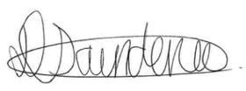
Headteacher: Anna Edwards Signature:
Chair of Governors: Donna Saunders Signature:
Review date: November 2027

